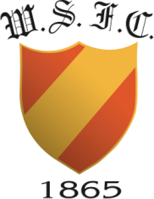

West of Scotland Football Club - Statement on Equality

West of Scotland Football Club is committed to equal opportunities and actively encourages participation and membership from all sectors of the community. Applications for membership will be considered on an equal basis regarding; religious belief, political opinion, racial group, ethnicity, age, marital status, sexual orientation, gender, ability; persons with a disability and persons without, persons with dependents and persons without.
West of Scotland respects the rights, dignity and worth of every person, and will treat everyone within the context of their sport by providing equality of opportunity for successful participation. The Club is committed to everyone having the right to enjoy their sport in an environment free from threat of intimidation, harassment and abuse.
All West of Scotland members have a responsibility to oppose discriminatory behaviour and promote equality of opportunity. The Committee will deal with any incidence of discriminatory behaviour seriously.
West of Scotland is fully committed to safeguarding the well-being of its members. Every individual in the Club should always show respect and understanding for the rights, safety and welfare of others, and conduct themselves in a way that reflects the principles of the Club.
Kind regards,
West of Scotland FC Committee

